Any resident of Woodside, The Glade or Commonside requiring a substantial delivery of materials that would normally be delivered on a large modern lorry should advise the delivery company of the maximum gross vehicle weight limit of 18T.
The following is a suggested document for people requiring large deliveries to give to their supplier:
IMPORTANT DELIVERY INSTRUCTIONS FOR
Address:
Telephone:

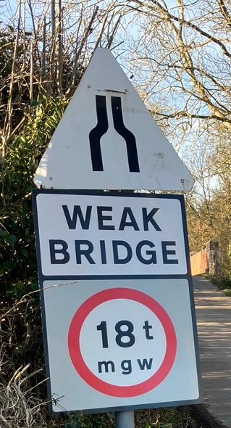
All Deliveries must be on vehicles with a maximum gross weight of no more than 18 tonnes due to the restrictions on The Glade bridge.

If the carrier cannot make alternative means of delivery by a smaller vehicle, they should contact Network Rail to obtain PRIOR permission to cross The Glade Bridge.
Contact the Network Rail Community Relations Team on their 24hr helpline on 03457 11 41 41 quoting “The Glade Overbridge Weight Restriction” and they will strive to process any requests involving vehicles exceeding 18T in a timely manner.
It may take time to get such matters dealt with.

